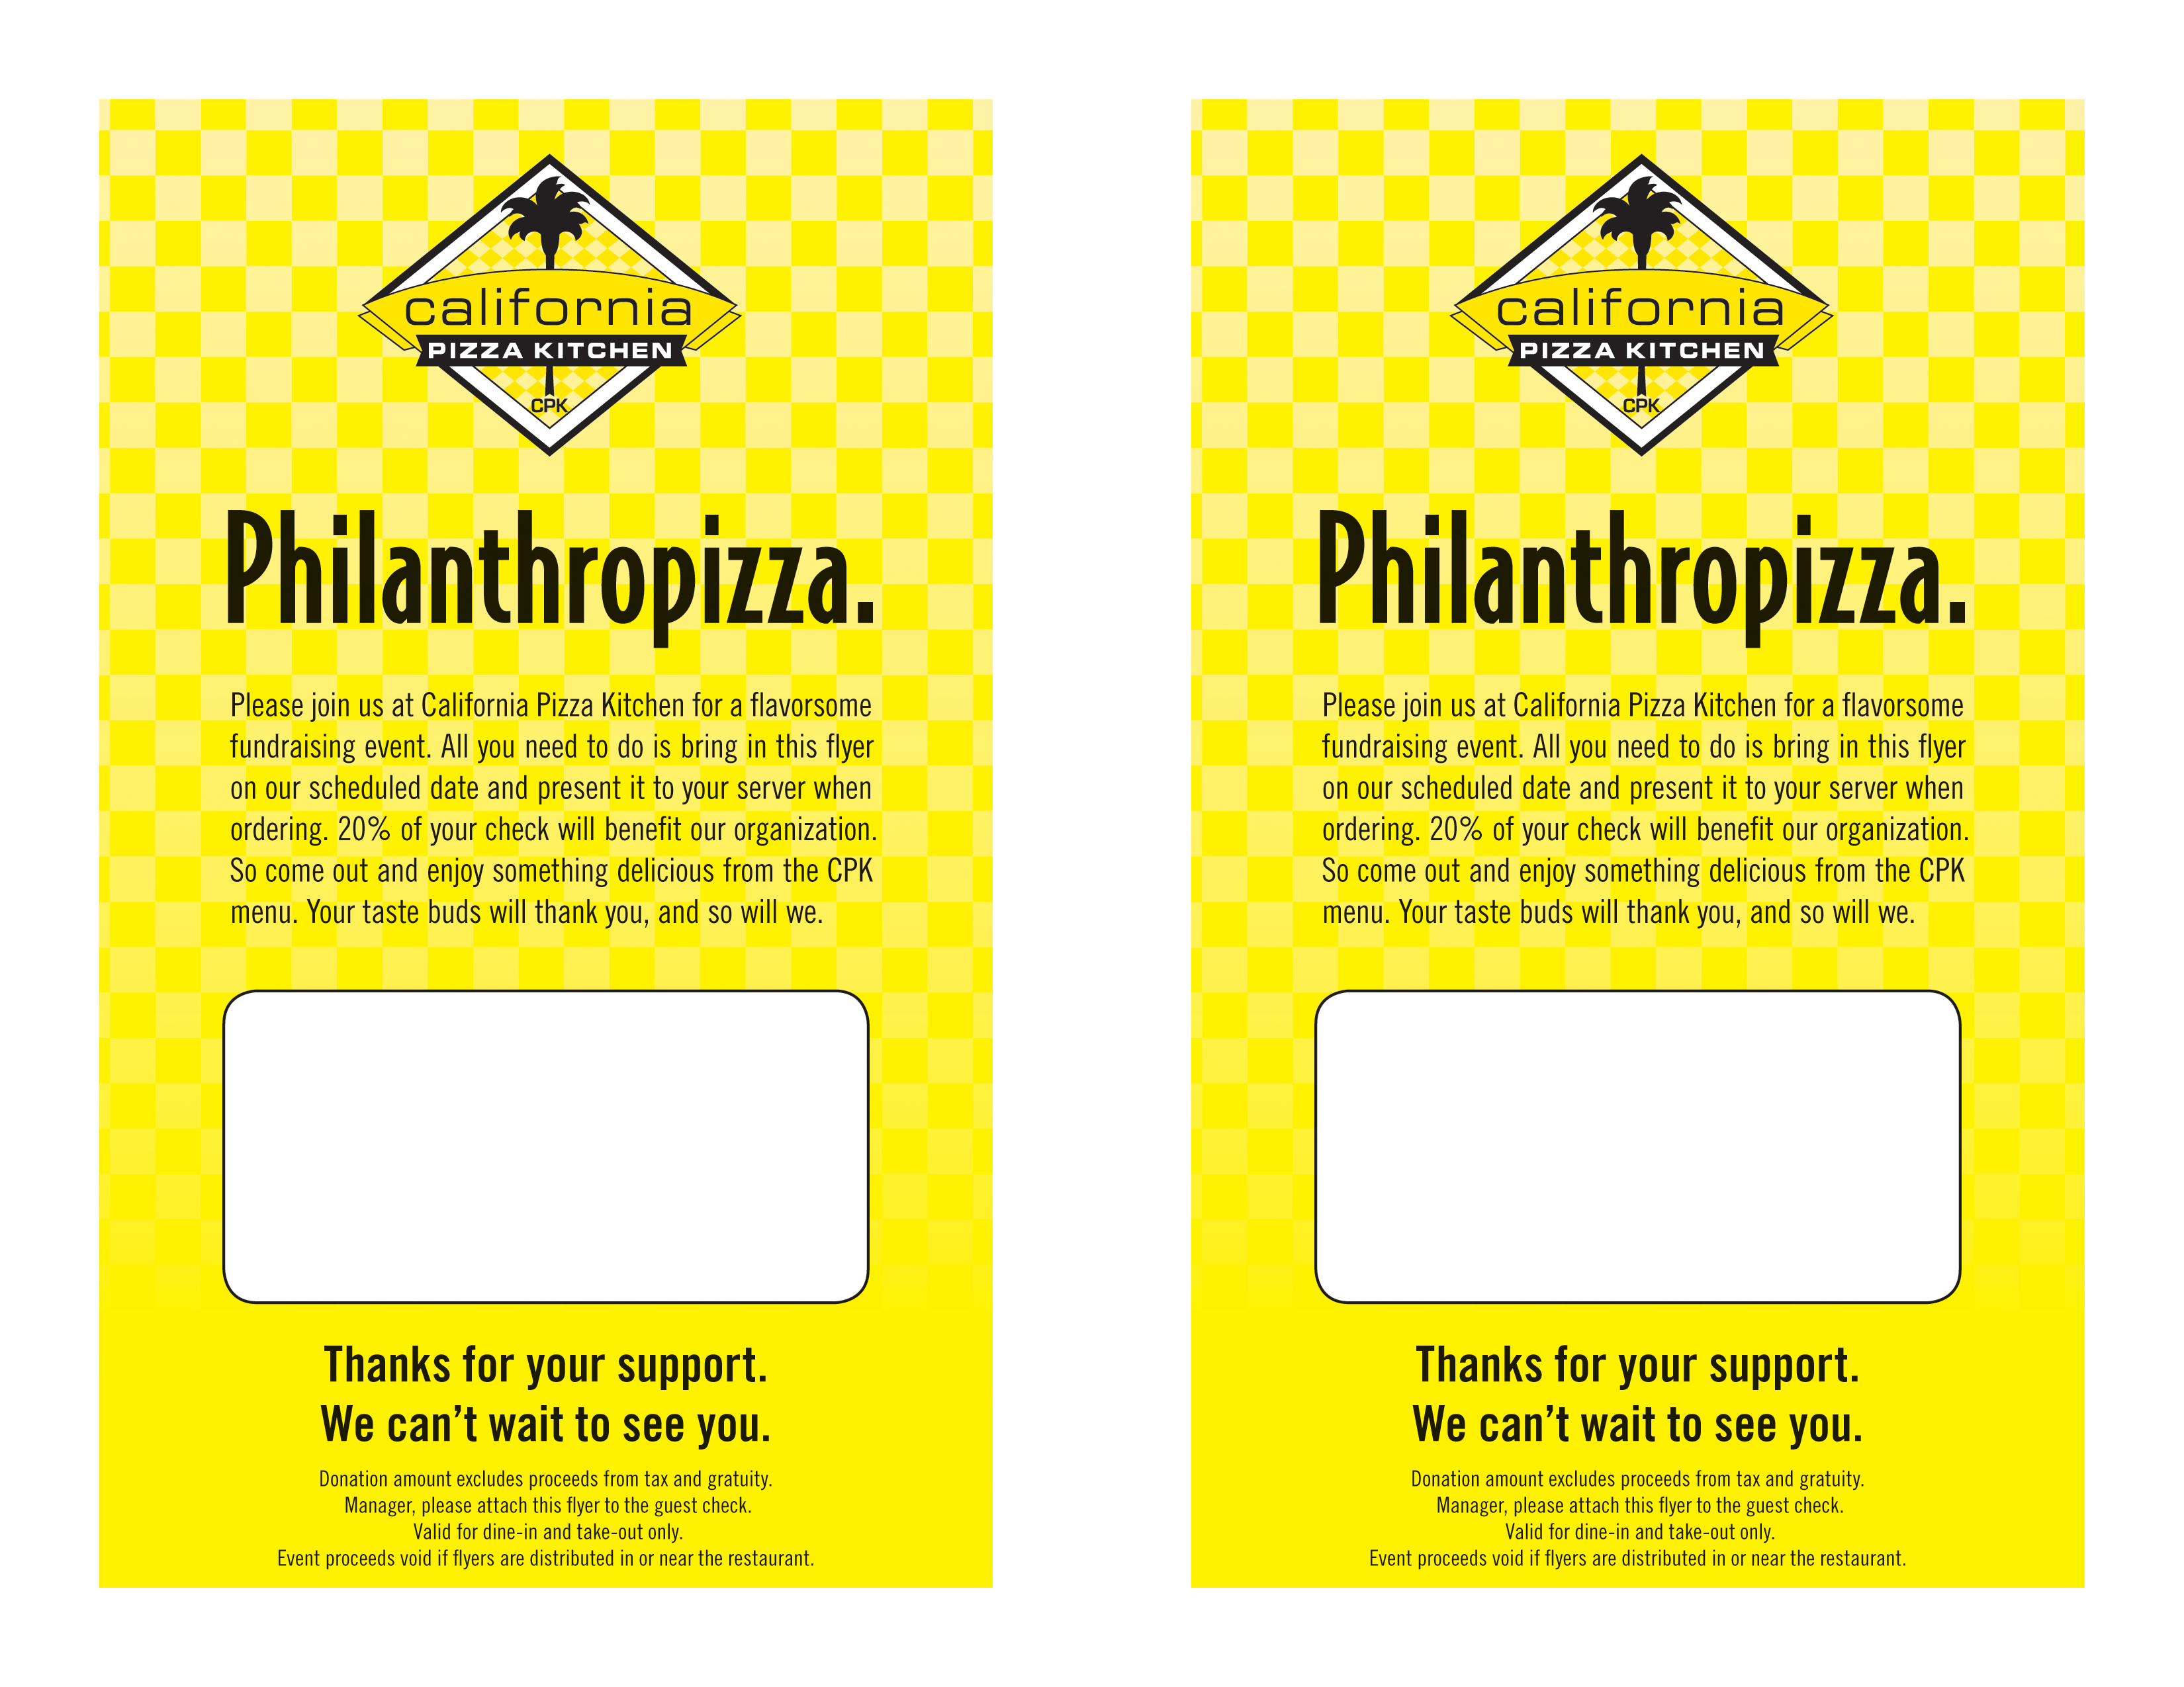
Azure Lorica

California Pizza Kitchen
99 Los Robles, Pasadena
626-585-9020

January 31st 2012
All day event

Azure Lorica

California Pizza Kitchen
99 Los Robles, Pasadena
626-585-9020

January 31st 2012
All day event

